**Title: Diabetic Retinopathy Classification Using Quantum Assisted Deep Learning (Hybrid Model)**

**Abstract:**

India, which is known as the "diabetic capital," is seeing an increase in cases of diabetic retinopathy (DR), which is expected to double over the next two to three decades. This disease, which results from diabetes, can cause blindness, and drastically shorten a person's life expectancy [1]. The main characteristic of DR is micro-vascular retinal alterations. To tackle this disease, early diagnosis by vision-based screening and classification algorithms is essential, but it requires significant computational resources. One promising approach to this problem is quantum computing. There are theoretical benefits and viability to combining quantum computing with traditional image categorization techniques. However, obtaining high accuracy has proven to be a challenge for the picture categorization methods now in use. Our work presents a quantum-based deep convolutional neural network as a solution to this. For the categorization of DR, our hybrid model combines quantum-assisted deep learning with Convolutional Neural Networks (CNNs). The quantum component processes complex and high-dimensional quantum data obtained from these scans, providing deeper insights into the molecular and cellular alterations associated with the disease, while the CNN evaluates retinal images, extracting relevant aspects. An extensive investigation of diabetic retinopathy is made possible by this integration [1]. The model helps with early diagnosis by properly predicting the severity of DR. We provide encouraging findings that demonstrate this hybrid model's potential to improve the precision and effectiveness of DR diagnosis. Our research intends to address the pressing healthcare issue of diabetic retinopathy diagnosis by utilising state-of-the-art CNN technology and quantum-assisted deep learning, providing substantial advantages to patients and physicians alike.

**Introduction:**

Within the field of medicine, India has become well-known for the rapidly increasing incidence of diabetic retinopathy (DR), a condition that has earned the country the title of "diabetic capital." Forecasts highlight the expected twofold rise in occurrences during the next twenty to thirty years. In addition to being closely associated with diabetes, DR is a serious risk factor for an individual's overall work output in addition to impairing eyesight [1]. The complex micro-vascular retinal alterations that are specific to DR highlight the urgent need for sophisticated, low-resource early detection techniques.

When it comes to the identification of diabetic retinopathy (DR), conventional methods have always struggled with subjectivity and variability, especially when it comes to ophthalmologists' manual assessments [1]. Although they have made significant strides in automated screening, machine learning algorithms and Convolutional Neural Networks (CNNs) have struggled to achieve the precision required for efficient disease management. These traditional methods may not be sufficient because to the intricacy of the retinal architecture and the dynamic nature of DR progression.

Even though machine learning algorithms can identify patterns in labelled data, they frequently have trouble processing the complex and subtle properties seen in retinal pictures. These algorithms can be affected by differences in image quality, and they might not have the depth necessary to identify minute alterations that point to early-stage DR. CNNs have demonstrated potential in the extraction of features from images; nevertheless, their effectiveness is dependent on the calibre and variety of the training data [2]. It could be difficult for traditional CNNs to pick up on the fine information necessary for an accurate diagnosis in the context of DR.

The hybrid model we propose has the potential to be a breakthrough because of the limitations of existing techniques. Our approach aims to overcome the limitations of conventional machine learning algorithms and CNNs by utilising quantum computing in addition to them. The deep learning component that uses quantum augmentation is ready to handle intricate, high-dimensional quantum data obtained from retinal scans, offering a more refined comprehension of the alterations in molecules and cells linked to drug resistance [3]. By combining the best aspects of both domains, this integration seeks to provide a more thorough and precise method of diagnosing diabetic retinopathy. In later parts, as we explore the details of our hybrid model, we want to demonstrate how effective it is in addressing the drawbacks of CNN and conventional machine learning techniques.

A fundamental component of our methodology is the use of quantum computing, specifically via a quantum-based deep convolutional neural network (Q-DCNN). This advanced model provides deeper insights into the molecular and cellular alterations linked to diabetic retinopathy (DR) by processing complex quantum data obtained from scans in addition to optimising the analysis of retinal pictures via CNNs.

Our hybrid model, which incorporates components of conventional image classification techniques, has the potential to completely transform the field of DR diagnosis. This hybrid approach not only has the intrinsic capacity to accurately anticipate the severity of DR, but it also has the potential to expedite the diagnostic process and allow for early intervention. The subsequent sections will elucidate the complex technical aspects of our hybrid model, thereby confirming its efficacy and ability to make a substantial contribution to the field of diabetic retinopathy diagnosis.

**Literature Survey:**

In recent research, a novel approach for diabetic retinopathy (DR) detection using a deep symmetric Convolutional Neural Network (CNN) was proposed [1]. This work aimed to assess the severity of diabetes through image analysisThere were several disadvantages of concentrating on a deep symmetric Convolutional Neural Network (CNN) for the diagnosis of diabetic retinopathy (DR). First of all, depending just on a conventional CNN could restrict its capacity to identify complex patterns and interrelationships in the data that are essential for precise diagnosis of deep learning. Compared with our hybrid model, which combines both CNN and quantum-assisted deep learning, this limitation becomes clear.

Similarly, EDR-NET, a lightweight Deep Neural Network architecture specifically designed for detecting referable diabetic retinopathy, was introduced [2]. The model demonstrated predictive performance comparable to existing state-of-the-art methods. The simplicity of EDR-NET may lead to a decreased capacity to acquire fine features and changes in retinal pictures, especially in more difficult situations [2]. On the other hand, our hybrid model aims to address these shortcomings by offering a more thorough and flexible method by combining both quantum-assisted deep learning and Convolutional Neural Network (CNN) integration.

Another approach involved the introduction of a multi-stream deep neural network within a boosting framework for the classification of DR severity [3]. Leveraging deep networks and Principal Component Analysis (PCA), this work aimed to capture both inter-class and intra-class variations. The use of PCA and deep networks may not be sufficient to manage the variety and complexity of visual features found in real-world situations. On the other hand, our hybrid model aims to address these issues by offering a dynamic and comprehensive solution by combining both Convolutional Neural Network (CNN) and quantum-assisted deep learning.

Machine learning classifiers, including the Gaussian Mixture Model (GMM), kNN, and SVM, were explored for diabetic retinopathy analysis [4]. The study involved the classification of retinopathy lesions from non-lesions, providing insights into the effectiveness of various machine learning techniques. The study emphasises that the reliance of traditional classifiers on preset characteristics and handmade representations may be a possible downside. Poor performance could arise from these models' inability to learn and adapt on their own to the complex and ever-changing patterns found in retinal pictures. On the other hand, our hybrid model, which combines quantum-assisted deep learning with Convolutional Neural Network (CNN), provides a more sophisticated method by enabling the model to automatically extract pertinent characteristics from the input.

Additionally, a comprehensive model integrating the Internet of Things (IoT) and deep learning for diagnosing diabetic retinopathy using retinal fundus images was proposed [5]. This Computer-Aided Diagnoses (CAD) model served as a powerful tool to assist experts in the diagnostic process. The possible reliance on IoT infrastructure and real-time communication is one possible drawback. The model's availability for diagnostic assistance may be hampered in situations where connectivity is scarce or inconsistent. Our hybrid model, on the other hand, combines quantum-assisted deep learning with Convolutional Neural Network (CNN) to provide a more self-contained approach that might be less dependent on continuous connectivity. This could potentially result in a more reliable and approachable solution for diagnostic support, particularly in a variety of demanding environments.

**Dataset Preparation:**

Our diabetic retinopathy detection research relies on a meticulously curated Kaggle dataset, encompassing five severity labels—No_DR, Mild, Moderate_DR, Proliferate_DR, and Severe—with each label comprising 1000 high-quality retinal images. This balanced and diverse dataset forms the basis for robust model training and evaluation across various diabetic retinopathy stages.

With the dataset's unique labels ranging from the lack of retinopathy to severe manifestations, our hybrid model can identify minute details and patterns linked to varying degrees of severity. Our dataset stands out for its outstanding image quality, which prioritises accurate and comprehensive depictions of retinal structures. The model's generalizability and efficacy in identifying diabetic retinopathy at different stages are improved by this emphasis on quality.

With a well-balanced label distribution and superior image quality, our dataset lays a solid foundation for the subsequent phases of our research. The meticulous curation ensures our hybrid model is well-equipped to navigate the complexities of diabetic retinopathy detection, contributing to the reliability and effectiveness of our research outcomes.

**Implementation:**

**1. Data Pre-Processing**

The process of implementation begins with the import of the required libraries, which include scikit-learn, TensorFlow, and OpenCV, and the preparation of the dataset. Carefully selected from Kaggle, the dataset comprises five thousand high-resolution retinal pictures, each labelled to indicate a particular state of diabetic retinopathy, from No_DR (no diabetic retinopathy) to Severe. After normalising the images to a range between 0 and 1, this dataset is split into training and testing sets, creating a strong basis for the ensuing model training and assessment.

**2. Implementing Quantum Circuit**

Importing the required libraries and defining the function "create_quantum_circuit(image_features)" are the first steps in the quantum circuit implementation process. This function uses Qiskit, an open-source software development platform for quantum computing, to generate a quantum circuit using an array of image features as input.

The quantum circuit is initialized with a quantum and classical register, both with a number of qubits equal to the number of features in the input image. The function then iterates through each feature, encoding it into quantum states using rotation gates. The pixel values of the image feature are first scaled to an appropriate range for quantum gates, typically [0, π]. This scaling ensures that the feature values are compatible with the rotation gates. A rotation gate (“ry”) is applied to each qubit based on the scaled feature value. Finally, a measurement operation is performed on all qubits, and the resulting quantum circuit is returned.

This quantum circuit serves as a crucial component for encoding image features into quantum states, paving the way for quantum-assisted deep learning.

**3. Quantum-assisted Deep Learning:**

The quantum circuit developed in the first stage is expanded upon in the quantum-assisted deep learning implementation. Using a dataset ("set1") as input, the "qsdl" function simulates the quantum circuit for each image in the dataset to produce a quantum data array.

The function initializes a numpy array ("quantum_data") to store the measurement outcomes for each image in the dataset. It then iterates through the images, creating a quantum circuit for each using the "create_quantum_circuit" function. The quantum circuit is transpiled and compiled for simulation using the Aer backend in Qiskit.

The simulator runs the quantum circuit, and the measurement outcomes are recorded. The binary outcomes are converted to integers, representing the state of the quantum system. These outcomes are then stored in the "quantum_data" array.

The quantum states that correspond to the features of every image in the dataset are represented in the "quantum_data" array that is produced. The integration of quantum information into the overall classification process is made easier by this quantum data array, which is a crucial component of the quantum-assisted deep learning model.

To summarise, the implementation uses quantum-assisted deep learning to use the potential of quantum states for improved classification in the context of diabetic retinopathy detection, and it smoothly integrates quantum circuits to encode image information. This demonstration shows a first step towards using quantum computing for image categorization applications.

**4.Implementing Hybrid Model**

The hybrid model for the identification of diabetic retinopathy combines two powerful paradigms: quantum-assisted deep learning for handling quantum-encoded characteristics and convolutional neural networks (CNNs) for traditional image data processing. The input data ("cnn_input") is subjected to convolutional operations with a "Conv2D" layer in the conventional image processing component. This layer uses 32 filters and a (3, 3) kernel size. The activation function "relu" introduces non-linearity, and the resulting spatial features are flattened into a one-dimensional vector ("cnn_flatten") using the "Flatten()" layer. Simultaneously, the quantum data input ("quantum_input") is introduced as a separate input layer. The fusion of classical and quantum data is achieved through concatenation using the "Concatenate()" layer, resulting in a combined feature space that captures both classical spatial features and quantum-encoded information.

The combined feature space then progresses through fully connected layers. The first dense layer ("dense1") consists of 128 neurons and utilizes the "relu" activation function. This layer enables the model to learn intricate representations from the amalgamated feature space, contributing to the model's ability to discern complex patterns associated with diabetic retinopathy. The final output layer consists of 5 neurons, representing the different severity levels of diabetic retinopathy. The "softmax" activation function is applied to generate probability scores for each class, facilitating multi-class classification.

The sparse categorical cross-entropy loss function and the Adam optimizer are used to assemble the hybrid model for model training and evaluation. Accuracy is one of the selected evaluation metrics. A thorough description of the model architecture is given by the "model.summary()" command, which includes details on the number of parameters, the kinds and forms of layers, and the information flow. Essentially, the hybrid model builds on the synergistic relationship between quantum-assisted deep learning and classical image processing to create a potential framework for improving the efficiency and accuracy of diabetic retinopathy identification. By combining classical and quantum data, one hopes to benefit from the advantages of both methods and advance our knowledge of the underlying characteristics of medical picture data.

Applying the quantum-assisted deep learning function ("qsdl") to a portion of the training images results in quantum data, which is then used in the model training procedure. Training the hybrid model requires both this quantum data and the accompanying classical picture data. Through training on the given training dataset, the model's parameters are optimised to improve the model's accuracy in classifying the severity levels of diabetic retinopathy.

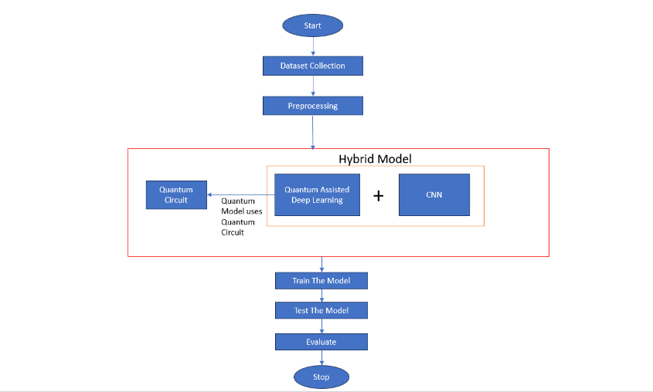

Fig 1: Architecture view of the model implementation

**Results :**

Two graphs are used to illustrate the model's training history. The training loss change over training epochs is shown in the first plot. It shows how effectively the model is reducing the discrepancy between the values that are predicted and those that are seen. The capacity of the model to accurately categorise examples is demonstrated by the second figure, which shows the training accuracy. These visuals provide a succinct synopsis of the learning dynamics and training performance of the model.

Predicted labels are generated from the model predictions for a selection of test images. Then, using a predetermined mapping, the actual classes matching to the predicted labels are printed. On the test subset, metrics including accuracy, precision, recall, and F1 score are computed to assess how well the model performs. The F1 score combines precision and recall, accuracy indicates the total right classification rate, while recall evaluates the coverage of real positive instances. The precision metric quantifies the accuracy of positive predictions. Based on the provided test data, these metrics offer a thorough assessment of the model's performance in identifying the various severity levels of diabetic retinopathy.

**Evaluation Metrics:**

|  |  |
| --- | --- |
| **Evaluation Metrics** | **Hybrid Model** |
| **Precision** | **88.91%** |
| **Recall** | **89.04%** |
| **F1-Score** | **88.66%** |
| **Accuracy** | **90% (89.999% aprox)** |

**Visualization Of the Graphs:**

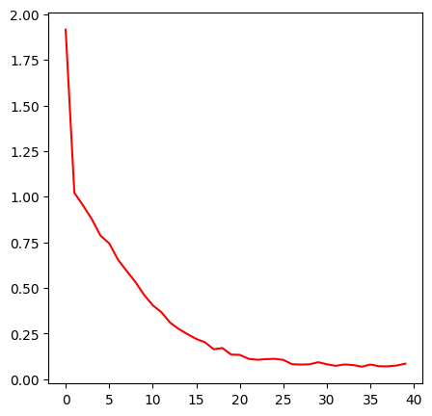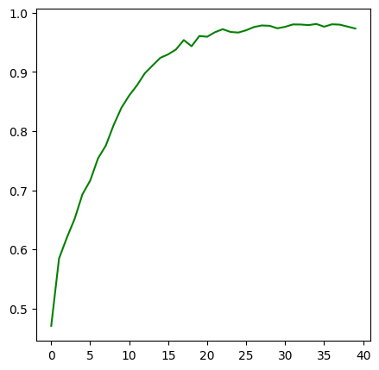

Fig 2: Accuracy Visualization Fig 3: Loss Visualization

**Sample Results:**

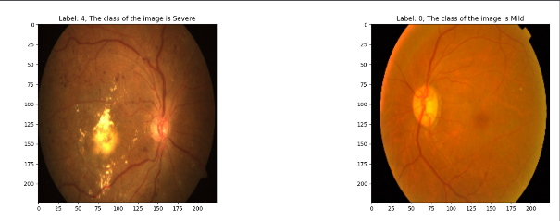

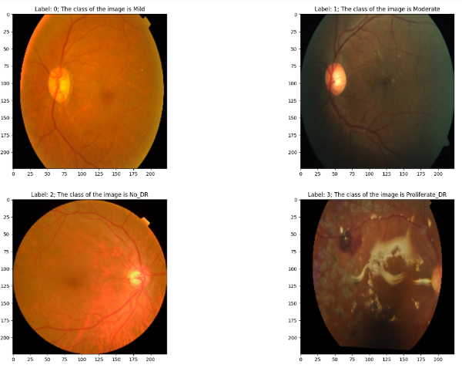

Fig 4 : Samples of test data during model prediction

**Conclusion:**

In summary, our research introduces an innovative hybrid model combining traditional image processing with quantum-assisted deep learning for the detection of diabetic retinopathy. The model, integrating Convolutional Neural Networks (CNNs) and quantum features, shows promising results in accurately classifying different severity levels of the disease. Looking ahead, the future scope involves expanding the dataset, optimizing quantum circuits, fine-tuning the model, exploring real-world deployment, and enhancing interpretability. By addressing these aspects, the hybrid model holds great potential to become a valuable tool for early and precise diabetic retinopathy diagnosis, offering significant benefits for patient care and healthcare systems.

**References:**

**[1]** Liu, Tieyuan, et al. "A novel diabetic retinopathy detection approach based on deep symmetric convolutional neural network." *IEEE Access* 9 (2021): 160552-160558.

**[2]** Aujih, Ahmad Bukhari, et al. "EDR-Net: Lightweight deep neural network architecture for detecting referable diabetic retinopathy." *IEEE Transactions on Biomedical Circuits and Systems* 16.3 (2022): 467-478.

**[3]** Mustafa, Hamza, et al. "Multi-stream deep neural network for diabetic retinopathy severity classification under a boosting framework." *IEEE Access* 10 (2022): 113172-113183.

**[4]** Ramya, Ms SP. "Diabetic Retinopathy Analysis Using Machine Learning." *Turkish Journal of Computer and Mathematics Education (TURCOMAT)* 12.9 (2021): 2930-2937.

**[5]** Palaniswamy, Thangam, and Mahendiran Vellingiri. "Internet of Things and Deep Learning Enabled Diabetic Retinopathy Diagnosis Using Retinal Fundus Images." *IEEE Access* 11 (2023): 27590-27601.